Python- Dictionary

A Python dictionary is a data structure that stores data in key-value pairs, where each key is unique and is used to retrieve its associated value. It is mainly used when we want to store and access data by a name (key) instead of by position like in a list.
Example: This example shows how a dictionary stores data using keys and values.
data = { "name": "Jake", "age": 22 }
print(data)
Output:
{'name': 'Jake', 'age': 22}
Explanation:
- "name" and "age" are keys
- "Jake" and 22 are their values
- dictionary stores data in key : value format

Creating a Dictionary:
A dictionary is created by writing key-value pairs inside { }, where each key is connected to a value using colon (:). A dictionary can also be created using the dict() function.

Example:
student = {"Isha":89, "Bhakti":89, "Rutuja":92, "Saniya":85, "Sanika":79}#1
print("The student dict is:", student)
Output:
The student dict is: {'Isha': 89, 'Bhakti': 89, 'Rutuja': 92, 'Saniya': 85, 'Sanika': 79}

Accessing Dictionary Items:
A value in a dictionary is accessed by using its key. This can be done either with square brackets [ ] or with the get() method. Both return the value linked to the given key.

Example:
print("The marks of the student Bhakti is:", student["Bhakti"])
Output:
The marks of the student Bhakti is: 89

Adding and Updating Dictionary Items
New items are added to a dictionary using the assignment operator (=) by giving a new key a value. If an existing key is used with the assignment operator, its value is updated with the new one.
Example:
student["Aditi"] = 76 #ADD
print("The student dict after adding new student is:", student)
student["Bhakti"] = 98 #UPDATE
print("The student dict after updatation is:", student)
Output:
The student dict after adding new student is: {'Isha': 89, 'Bhakti': 89, 'Rutuja': 92, 'Saniya': 85, 'Sanika': 79, 'Aditi': 76}
The student dict after updatation is: {'Isha': 89, 'Bhakti': 98, 'Rutuja': 92, 'Saniya': 85, 'Sanika': 79, 'Aditi': 76}

Removing Dictionary Items
Dictionary items can be removed using built-in deletion methods that work on keys:
- del: removes an item using its key
- pop(): removes the item with the given key and returns its value
- clear(): removes all items from the dictionary
- popitem(): removes and returns the last inserted key–value pair

Example:
del student["Aditi"]
print("The student dictionary after del is:", student)
Output:
The student dictionary after del is: {'Isha': 89, 'Bhakti': 98, 'Rutuja': 92, 'Saniya': 85, 'Sanika': 79}

Iterating Through a Dictionary
A dictionary can be traversed using a for loop to access its keys, values or both key-value pairs by using the built-in methods keys(), values() and items().

Example:
print("All the student names are:", student.keys())
print("All students marks are:", student.values())
print("All students name with their marks are:", student.items())
Output:
All the student names are: dict_keys(['Isha', 'Bhakti', 'Rutuja', 'Saniya', 'Sanika'])# .keys()
All students marks are: dict_values([89, 98, 92, 85, 79])#.values()
All students name with their marks are: dict_items([('Isha', 89), ('Bhakti', 98), ('Rutuja', 92), ('Saniya', 85), ('Sanika', 79)])#.items()

Nested Dictionaries
A nested dictionary is a dictionary that contains another dictionary as one of its values. Below diagram shows how a nested dictionary works, where key 3 points to another dictionary inside the main dictionary.
Example:
student_details = {
"Isha":{"age":22, "grade":90, "department":"IT"},
"Bhakti":{"age":21, "grade":98, "department":"AIDS"},
"Rutuja":{"age":20, "grade":91, "department":"IT"}
}
print("The nested dictionary is:", student_details)
Output:
The nested dictionary is: {'Isha': {'age': 22, 'grade': 90, 'department': 'IT'}, 'Bhakti': {'age': 21, 'grade': 98, 'department': 'AIDS'}, 'Rutuja': {'age': 20, 'grade': 91, 'department': 'IT'}}

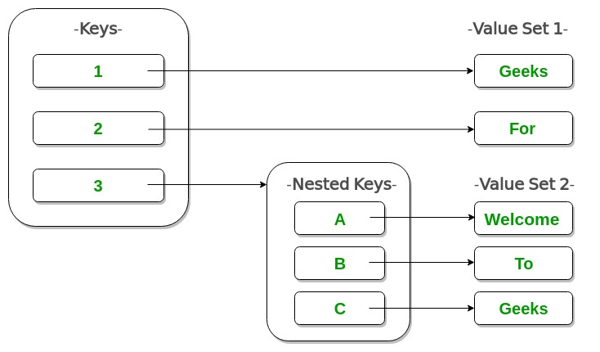

List of Python Dictionary Methods
Python provides several built-in methods for dictionaries that allow for efficient manipulation, access, and transformation of dictionary data. Here's a list of some important Python dictionary methods:

Functions Name | Descriptions
clear() | Removes all items from the dictionary
copy() | Returns a shallow copy of the dictionary
fromkeys() | Creates a dictionary from the given sequence
get() | Returns the value for the given key
items() | Return the list with all dictionary keys with values
keys() | Returns a view object that displays a list of all the keys in the dictionary in order of insertion
pop() | Returns and removes the element with the given key
popitem() | Returns and removes the item that was last inserted into the dictionary.
setdefault() | Returns the value of a key if the key is in the dictionary else inserts the key with a value to the dictionary
values() | Returns a view object containing all dictionary values, which can be accessed and iterated through efficiently
update() | Updates the dictionary with the elements from another dictionary or an iterable of key-value pairs. With this method, you can include new data or merge it with existing dictionary entries

- Dictionary Comprehension
Dictionary comprehension is used to create a dictionary in a short and clear way. It allows keys and values to be generated from a loop in one line. This helps in building dictionaries directly without writing multiple statements.
Example: This example creates a dictionary where numbers from 1 to 5 are used as keys and their squares are stored as values.
sq = {x: x**2 for x in range(1, 6)}
print(sq)
Output:
{1: 1, 2: 4, 3: 9, 4: 16, 5: 25}

Explanation:
- x takes values from 1 to 5 and x becomes the key
- x**2 becomes the value
- Each key and value pair is added to the dictionary in one line

Syntax:
{key: value for (key, value) in iterable if condition}
- key: The item to use as the dictionary key.
- value: The item to use as the dictionary value.
- iterable: Any sequence or collection to loop through.
- condition (optional): Lets you include only certain items

Creating a Dictionary from Two Lists
This method creates a dictionary by pairing each item from one list with the matching item from another list using zip().
keys = ['a','b','c','d','e']
values = [1, 2, 3, 4, 5]
Example:
d = {k:v for (k,v) in zip(keys, values)}
print (d)
Output:
{'a': 1, 'c': 3, 'b': 2, 'e': 5, 'd': 4}

CASE STUDY - DICTIONARY
